**Preparing a Print in Illustrator**

This tutorial is about how to print something from Adobe Illustrator once you have finalized your design. The user is assumed to have some knowledge of the basic commands.

Laser Modes

1. The laser cutter has two modes; 1) Raster and 2) Vector. To help understand and remember the differences, here is the definition of raster and vector:
   1. Raster - a rectangular pattern of parallel scanning lines.
   2. Vector - a quantity having direction as well as magnitude

In raster mode, the laser moves rapidly along the X-axis while moving slowly in the Y-axis thereby making a zig-zag pattern, similar to that of a raster scan. Raster mode is used for ENGRAVING only.

On the other hand, vector mode is used for CUTTING. The laser is given a direction and distance to move based on your artwork.

1. Cutting
   1. Lines in illustrator that have a stroke weight of 0.001” (0.072 pt) will be recognized as outlines and will be vector cut. (To display the stoke weight as inches, go to Edit / Preferences / Units / and from the dropdown next to Stroke click inches).

Printer Setup

1. Go to File / Print
2. From the dropdown next to Printer, choose the Epilog Engraver

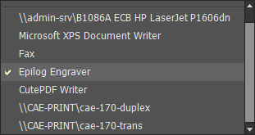

1. In the Options section next to Placement, click on the upper-left square to place your work in the upper-left corner (if you can’t find the square, type in 0 for both X and Y). In addition, make sure the dropdown next to Scaling says Do Not Scale (unless you want your artwork to be larger/smaller than drawn).

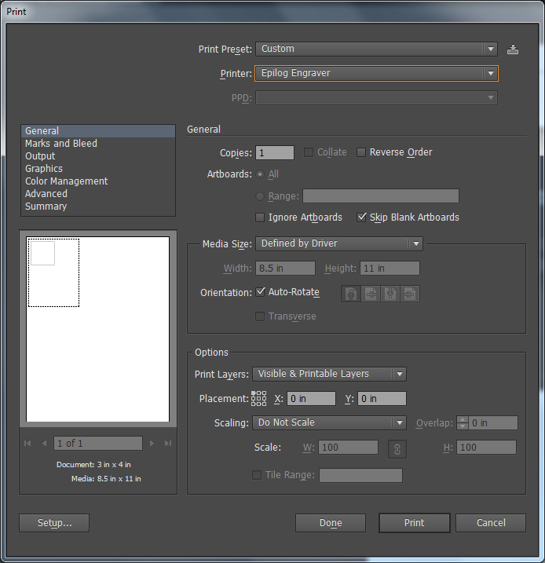Kl

1. In the lower-left corner of the Print dialog box, click on the button labeled as Setup… A warning will appear telling you that Adobe Illustrator can’t guruantee greatness if you mess with the printer’s preferences outside of the Print dialog box. Click continue to move pass the warning.



1. With the Epilog Engraver highlighted, click on the button labeled Preferences to launch the Epilog Printing Preferences.

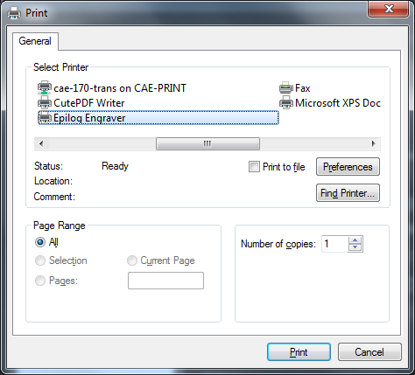

1. On the General Tab and in the Resolution panel, you can change the resolution (obviously) of the printing. Anything above 300 DPI is nearly identical so it is suggested that the 600 DPI value be left alone. However, if you wish to change the resolution, click on the blue slider bar to move it up or down.

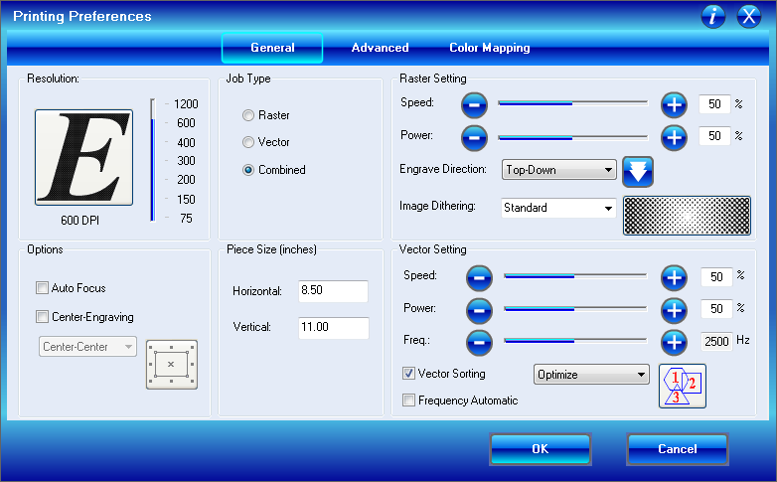

1. In the Options panel, you can select if you want the machine to Auto Focus or move the Home Position to a different location other than the upper-left corner (useful for non-flat objects). Most of the times the settings should like those set in the image below.



1. In the Job Type panel there are three options to choose from. By selecting Raster, you are telling the printer that there is nothing to be cut out so it will engrave your art work. By selecting Vector, you are telling the printer that there is nothing to engrave so it will only cut on the lines that are 0.001” wide. By selecting Combined, the printer will first perform the engraving with the raster settings, and then cut along the lines with the vector settings.
   1. WARNING: If your artwork has lines that are 0.001” in width without your knowledge and you are running in Combined mode, the printer will cut along those lines resulting in your artwork falling to pieces (literally).



1. In the Piece Size panel, you can type in the size of your work piece.



1. In the Raster Setting panel, you can modify the speed of the laser carriage, the power of the laser, the engrave direction (almost always down), and image dithering (unless you know what you are doing, choose Standard). Starting numbers for the laser power and speed are located at the end of this document.



1. In the Vector Setting panel, you can modify the speed of the laser carriage, the power of the laser, and the frequency at which the laser is powered. In addition, you can set whether Vector Sorting is turned on, the order in which things the laser will cut along vector paths, and whether or not to have the frequency set to automatic.



1. On the Advanced tab, you can choose the Raster Type for when you are engraving. These settings should be left at basic unless you have the permission of a Shop Staff member.

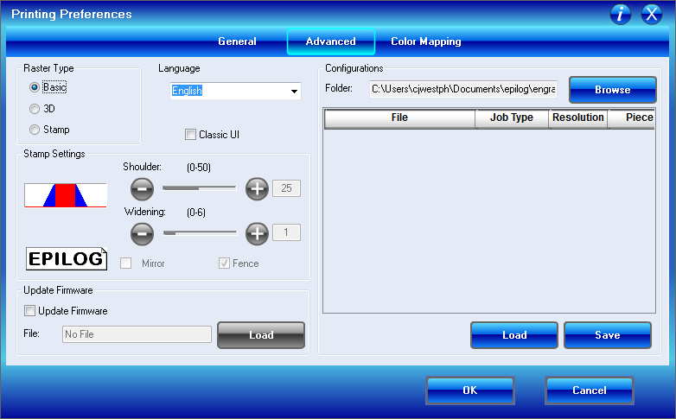

1. Lastly, on the Color Mapping tab, you can turn on the Color Mapping feature that allows you to color code your artwork so that it corresponds to different settings (e.g. red lines could be vector cut at 100% power and speed at 500Hz while green line are vector cut at 50% power and speed at 1000Hz).

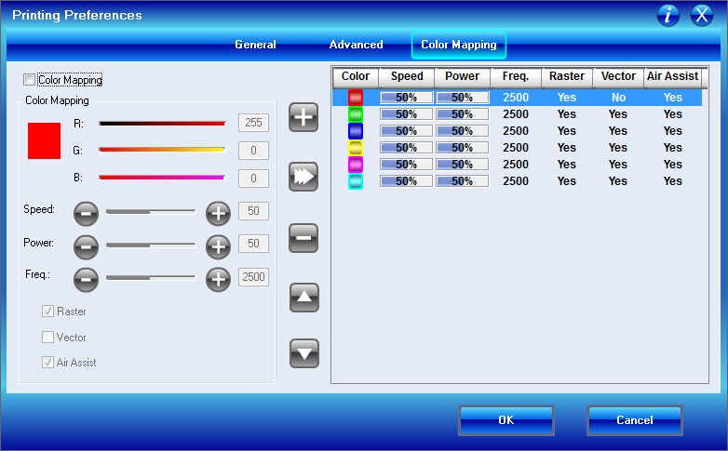

To add a color

* 1. Click on the check box next to Color Mapping
  2. Select what color to use by moving the RGB sliders.
  3. Adjust your settings for speed, power and frequency.
  4. Choose the mode that you wish (i.e. Raster, Vector, or both)
  5. Always choose Air Assist
  6. Click the button with a ‘+’ to add your new color to the list.

To modify a color

1. Click on a color you wish to modify.
2. Modify the settings to your liking.
3. Click the button labeld ‘≫’

To remove a color

1. Click on the color you wish to remove
2. Click on the button labeled ‘-‘

To move a color up or down

1. Click on the color you wish to move
2. Click on the button labeled with the arrow up or the arrow down
3. Once you have completed these settings, click the button labeled OK.



1. Click the button labeled Print

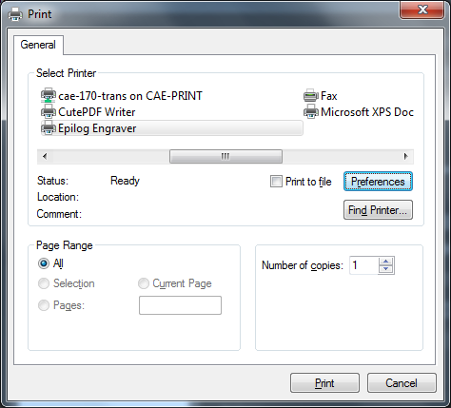

1. Ensure that the Epilog Engraver is turned on and click the button labeled Print in Illustrator. This will send the file to the engraver.

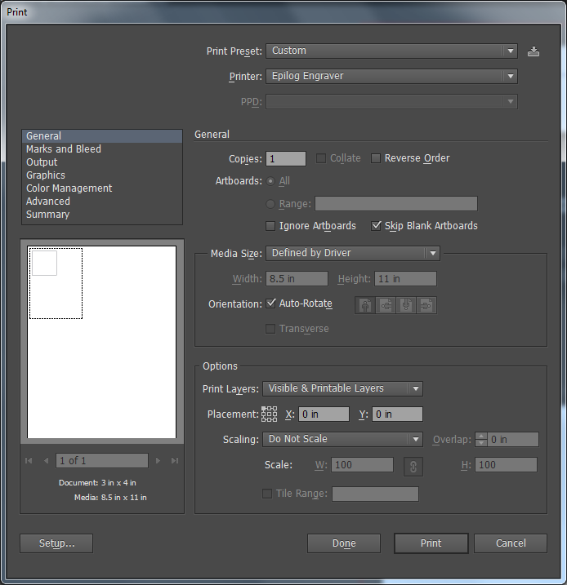

1. At the printer, follow the instructions labeled Running the Engraver.